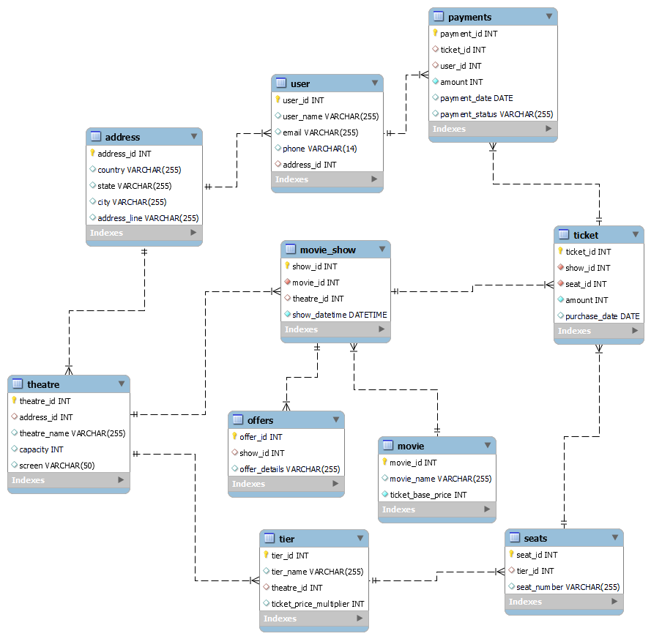
1️⃣ User Registration & Login
Entities Involved: user, address
📌 Flow:
✅ New users sign up by providing their name, email, phone, and address.
✅ The user information is stored in the user table.
✅ Returning users log in using their email or phone.

2️⃣ Movie Selection
Entities Involved: movie
📌 Flow:
✅ The user browses available movies in the system.
✅ Movie details are fetched from the movie table, including:
- Movie Name
- Ticket Base Price
✅ The user selects a movie to book a ticket.

3️⃣ Select Theatre & Show Timing
Entities Involved: theatre, address, movie_show
📌 Flow:
✅ After selecting a movie, the user picks a theatre from the list.
✅ The system fetches available theatres from the theatre table.
✅ The user selects a show timing from the movie_show table.

4️⃣ Choose Seats & Tiers
Entities Involved: seats, tier
📌 Flow:
✅ The user views available seats in the selected theatre.
✅ Seats are categorized into tiers (tier table):
- Premium
- Standard
- Economy
✅ The user selects one or more seats from the seats table.
✅ The system calculates the price based on the ticket_price_multiplier from the tier table.

5️⃣ Apply Offers (Optional)
Entities Involved: offers
📌 Flow:
✅ The system checks for any available offers for the selected show in the offers table.
✅ If the user applies an offer, the system updates the ticket price accordingly.

6️⃣ Ticket Booking & Payment
Entities Involved: ticket, payments
📌 Flow:
✅ The system generates a ticket entry in the ticket table with:
- show_id (from movie_show)
- seat_id (from seats)
- amount (final price after applying offers)
- purchase_date
✅ The user proceeds to payment, and a new entry is added to payments table with:
- user_id (who booked the ticket)
- ticket_id
- amount
- payment_status (Pending/Completed)
✅ Once payment is successful, the ticket is confirmed.

7️⃣ Ticket Confirmation & Booking Details
Entities Involved: ticket
📌 Flow:
✅ After successful payment, the system generates a ticket confirmation with:
- Movie Name
- Theatre Name
- Show Timing
- Seat Number(s)
- Total Amount Paid
✅ The user can download or view their ticket details.

8️⃣ User Can View Booking History
Entities Involved: ticket, payments
📌 Flow:
✅ The user can view past ticket bookings from the ticket table.
✅ Payment history is fetched from the payments table.

1️⃣ Ticket Cancellation & Seat Release
Entities Involved: ticket, seats, payments
📌 Flow:
✅ The user can cancel a booked ticket before the show starts.
✅ When a ticket is canceled:
- The corresponding seat_id is marked as available in the seats table.
- The ticket_status in the ticket table is updated to Canceled.
- If the payment was completed, the payment_status in the payments table is updated to Refund Initiated.
✅ If eligible, the system processes a refund based on the cancellation policy.
✅ A notification is sent to the user about the cancellation and refund status.

2️⃣ Seat Status (Available / Booked) Display
Entities Involved: seats, ticket
📌 Flow:
✅ Each seat has a status field in the seats table:
- Available → Not booked, can be selected.
- Booked → Already reserved, cannot be selected.
✅ When a user books a seat, the status changes from Available → Booked.
✅ When a ticket is canceled, the seat status updates back to Available.
✅ The front-end UI updates seat colors to reflect availability (e.g., green for available, red for booked).

🌟 Summary of Steps:
1️⃣ User Registers/Login
2️⃣ Selects a Movie
3️⃣ Chooses Theatre & Show Timing
4️⃣ Selects Seats & Tiers
5️⃣ Applies Offers (if any)
6️⃣ Confirms Booking & Pays
7️⃣ Receives Ticket Confirmation
8️⃣ Can View Booking History

